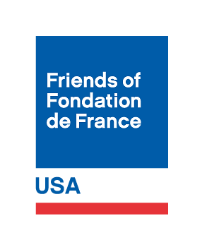

**Donation Form**

*Please print this form and mail it to Friends of Fondation de France.*

I would like to make a gift of: $

I would like my donation to go to (name of specific program or fund):

Name:

Address:

City:

State:

Zip Code:

Email Address:

Telephone number:

Please make your check or money order payable to

**Friends of Fondation de France**.

Please mail your gift to:

Friends of Fondation de France

572 Valley Road, Unit 43019

Montclair, NJ 07043

**Thank you for your donation!**